“American dream houses, all in a row”
John Blackwell
The Trentonian

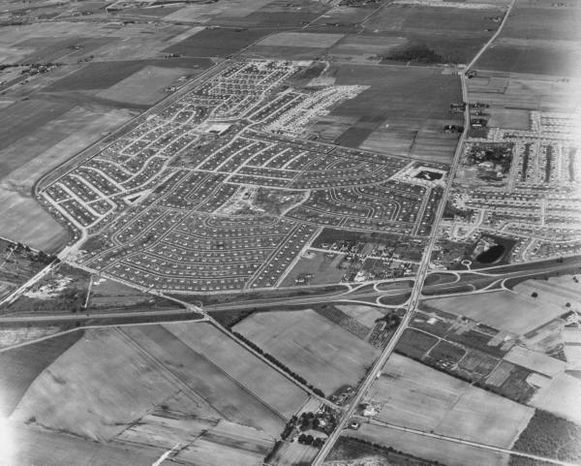
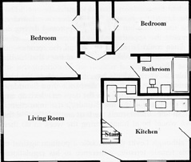
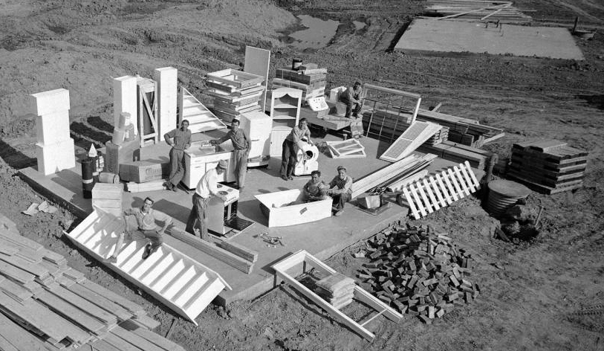
William Levitt had already established himself as America's biggest housebuilder in 1951 when he looked upon a green expanse of woods and spinach farms in bucolic Bucks County, Pa., and dreamed of instant suburbia.
Here, a ranch house. There, a Cape Cod. As far as his mind's eye could see, a sprawl of boxlike, two-bedroom houses — a city named Levittown.
Pieces of the American Dream were a hot commodity in post-World War II America, and nobody could sell them like Levitt. When he marketed his mass-produced homes in beautiful color brochures, thousands of young families wanted to buy.
They came to escape crowded cities like Trenton, eight miles northeast, or Philadelphia, 20 miles south. They came to own their own home, cook with their own appliances, mow their own lawn. They had GI loans in hand, babies on the way, and a ‘50s brand of pioneering spirit.
"Bill Levitt didn't just build a community here — he built a world," said Hal Lefcourt, an Army veteran who left Hamilton Township 47 years ago to move into his Levitt house — and still lives in Levittown today.
"We were young, all of us who moved to Levittown, and we thought Bill Levitt was the greatest man in the world. Imagine it — $10 deposit, $90 at settlement, and you had a house of your own!"
Levittown was a fresh marvel of modern planning to a Northeast corridor bursting at its seams in the early 1950s.
The young men of Lefcourt's generation had grown up amid Great Depression hardship and gone overseas to win the most awful war in history. They came back in 1945, entitled to housing loans and college educations under the GI Bill of Rights. Yet when they went shopping for a home, there seemed to be no sellers.
The housing shortage in Trenton was a scandal to The Trentonian, the city's brash new daily paper that served as a voice for working people and young veterans. Day after day, it published heartbreaking stories of evictions and voiced outrage over the city fathers' failures to build affordable housing.
But there was simply no room for new houses in a 7½-square-mile, aging industrial town like Trenton.
The construction took place in Hamilton and Ewing as hastily paved side streets filled up with bungalows and garden apartments. New highways, like the widened Route 1 and the New Jersey Turnpike, blazed the trail for suburbanites to work in the city and live somewhere miles away.
Greater Trenton was on the move like never before in the 1940s: while the city population went up by just 2.7 percent, the suburbs gained 40 percent more people!
Into this burgeoning growth, which knew no city limits, United States Steel announced plans for a giant steel mill in Falls Township, Pa., in late 1950. Benjamin Fairless, president of U.S. Steel, bought up acres of nearby farmland to develop into 4,000 houses. The real-estate market went wild: landowners who once couldn't sell at $300 an acre were suddenly being offered six times that.
And then Bill Levitt stepped in and made even that speculation look puny.
He'd made his name building Levittown, N.Y., the miracle suburb on Long Island that opened the way for the middle class to move out of New York City. Now Levitt proposed to do the same for suburban Philadelphia and Trenton.
His plan, unveiled in July 1951, went far beyond providing homes for steelworkers. He would create his own city, 17,311 houses in all between Routes 1 and 13. They would be built cheaply, and quickly.
It took only $100 — yes, $100 — to make a down payment on a Levittown home. Levitt, a dapper salesman with wavy hair and a pencil-thin mustache, called it democracy in real estate. "We believe," he said in one promotional film, "that every family in the United States is entitled to decent shelter."
In private, Levitt explained his philosophy another way: "Any damn fool can build homes. What counts is how many can you sell for how little."
Volume, volume, volume. That was the key to profit for the $200 million Levittown, Pa., project. Every piece of lumber was numbered, every cement-coated nail accounted for, every task in the house-building process given to a different team.
A truck would pull up to one tract and pour the concrete for a house foundation. Then it would move on to the next lot, and the next, and the next. Less than a week later, a construction team would be hammering wood frames into place. At that rate, Levittown houses could be built at the rate of 18 in the morning, 18 at night.
In the fall of ‘51, Levitt opened his first model house, a rancher he called the "Levittowner." It came with radiant heating, roofed carport, Bendix washer and General Electric stove. There was no basement, no second story.
In short, it was like all Levitt houses. Helen DiGiovanni visited one that fall of ‘51 with her husband, Al, and fell in love with it. "It was the windows," she said. "All the way to the floor, and made of Thermopane. We came from Philadelphia, where everything was rowhouses, and I'd never seen anything like it."
Al DiGiovanni had already put a down payment on a house in North Philly, but his wife convinced him that Levittown was the place to be. He not only agreed and decided to move out there, but took a job with the Levitt firm — and found himself landscaping the same houses he would be living in.
"Bill Levitt's old man, Abraham, was always there, telling people where to plant that tree, how to trim that bush," Al DiGiovanni recalled. "Everything was piecework. I'd make $35 a day, and my old uncle said, ‘Not even the president of the United States makes that kind of money!'"
Unlike Levittown, N.Y., which arose in an improvised frenzy, Levittown, Pa., was planned down to the last shrub and sewer grating. No residential intersection had four corners. No school child would ever have to cross a main street to walk to school.
The first houses ready for residents came in only two styles, a rancher with a front door facing the street and a variant with the main entry facing the side of the house next door. Eventually, Levitt added two-story Cape Cods and colonials to style choices.
No two styles were ever built side by side. Still, the rows of houses looked so stupefyingly alike that even residents mixed them up. One newcomer, Reuben Sussman, later recalled telephoning for directions to his own house after driving around and around the neighborhood.
One handy way of navigating Levittown was to do it alphabetically. Every road in Golden Ridge, for instance, began with a "G" — Great Oak Road, Geranium Road, Gable Hill Road.
The road names had a soothing, rural sound. But moving-in day for the first Levittowners — June 23, 1952 — was muddy and boisterous. The grass lawns had not yet had time to mature, so families had to walk into their homes on wooden planks. Greeting them were an army of pushy salesman, hawking everything from milk delivery to diapers.
Levittown's first family was Mr. and Mrs. Harold Rumple, formerly of Edgely, Pa. Interviewed by the Levittown Times, Harold Rumple marveled at his moving-day presents, courtesy of the salesmen: 3 quarts of milk, a pint of cream, a pound of butter, a dozen eggs, two loaves of bread and a certificate for a free dry-cleaning. "I'll have to move to a different house every two weeks," he said.
Hal Lefcourt arrived in August. Hal was athletic director at the Trenton Young Men's Hebrew Association; he and his wife, Sylvia, had lived in an apartment on South Broad Street, Hamilton. It was such a cramped lifestyle, they had put off any thought of becoming parents until they could buy their first home. Then they'd found a Levittowner for $10,000.
When Sylvia Lefcourt first set eyes upon their new home at 15 Spring Lane, the lawn was dusty and the paint job was unfinished. She broke into tears — of joy. "We had achieved the American Dream," said Hal Lefcourt, who still chokes on the emotion when repeating the story.
Three of the Lefcourts' friends bought adjacent lots on the same street so they could have their own backyard barbecues and neighborly confabs. All four families had babies within a year of their move. To look out for each other, they strung an intercom system between each home so each mother could hear the crying from the other house.
Suburbs like Levittown were the cradle for a generation of baby boomers, and became the model for the middle-class bedroom community.
In 1958, Levitt crossed the Delaware River and set up his third Levittown, this time an 11,000-house project in Willingboro, N.J. It was the third Levitt-created city, and the last in the United States — yet every suburban development built since then has borne the imprint of Bill Levitt's dream.
But was Levittown truly the fulfillment of American Dream?
From the day the first concrete foundation was poured, critics derided Levittown houses as shabby and lookalike and attacked the Levittown lifestyle as antlike in its conformity. Pete Seeger mocked suburbia in a 1962 song: "They're all made out of ticky-tacky, and they all look just like the same."
The early Levittowns also had an ugly secret: no black families allowed. "As a Jew, I have no room in my mind or heart for racial prejudice," Levitt insisted in 1954. "But, by various means, I have come to know that if we sell one house to a Negro family, then 90 to 95 percent of our white customers will not buy into the community. That is their attitude, not ours."
One black couple, Bill and Daisy Meyers, was daring enough to buy a Levittown, Pa. house in 1957. They were met by rock-throwers, bomb threats and mobs screaming racist taunts at them. It seemed like the bland facade of middle-class conformity was peeling away — to reveal hatred and fear underneath.
The Levittown "whites-only" policy eventually yielded to political pressure and lawsuits. Levittown, Pa. now has a mere fraction of blacks — just 1.5 percent — but Willingboro is split almost evenly between black and white. In a twist on ‘50s policy, real-estate agents now tout Willingboro's peaceful diversity as an attractive reason to move.
If racial tensions are not as obvious now, the look of Levittown has also undergone a transformation.
No longer does a rancher look every bit the same as another rancher, for homeowners have added their own individual touches. Carports have become bedrooms, second bathrooms attached to the back, even second stories placed square atop the roof.
Lefcourt sold his original $10,000 house and moved across the street. But the type of house he lives in is still a Levittowner. "And I'm a Levittowner, too," he said.
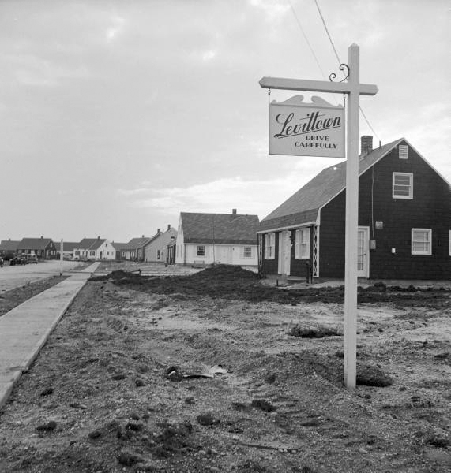

Text: www. http://www.capitalcentury.com/1951.html
Photos: http://tigger.uic.edu/~pbhales/Levittown.html

