RECENT & CONTEMPORARY AMERICA
Map Study: “Southeast Asia”

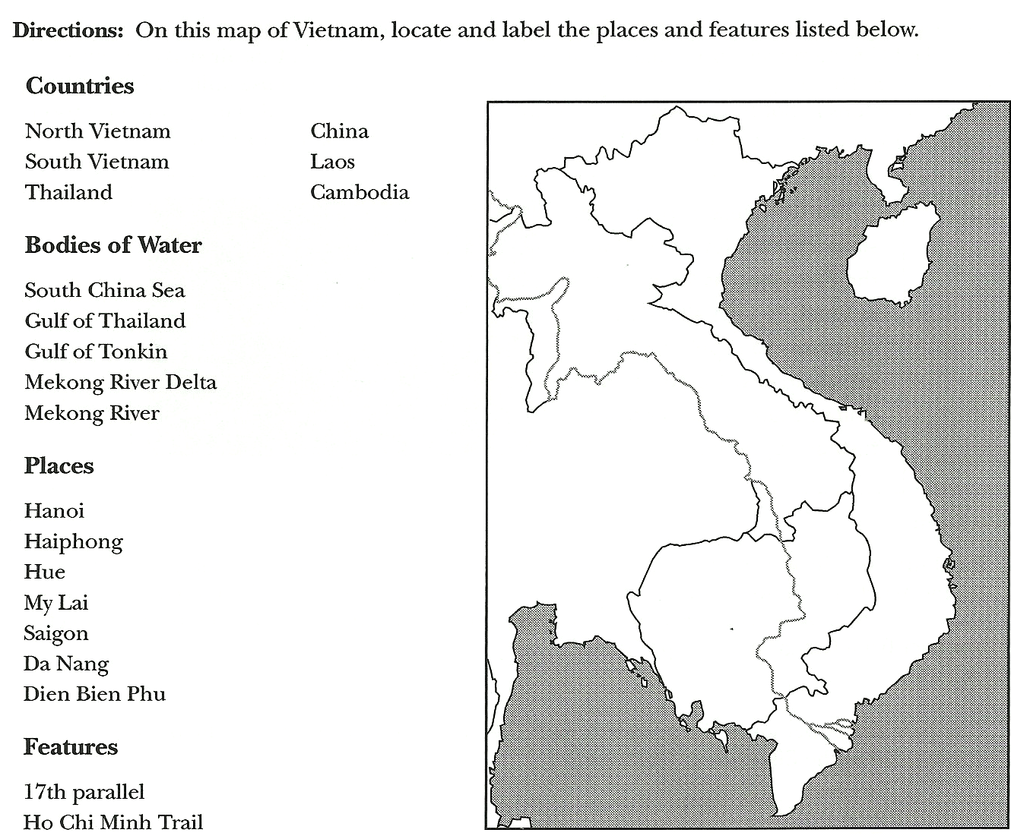

Focus on U.S. History: The Era of World War II Through Contemporary Times, J. Weston Walch, Publisher ©2000

